YMS NEWS BE SAFE, BE RESPECTFUL, BE RESPONSIBLE
JAN 18, 2019
GOLD DAY

YORK MIDDLE SCHOOL………..THE BEST MIDDLE SCHOOL IN NEBRASKA

TOLERANCE
Willingness to let others have opinions of follow practices different from one’s own own
WORD
OF THE
WEEK

1:00 DISMISSAL TODAY DUE TO WEATHER AND
NO SCHOOL MONDAY, JANUARY 21

CONGRATULATIONS TO YMS FFA MEMBERS AT DISTRICT FFA CONTEST***********
Sixteen teams were present with each team allowed 2 participants per event.
Discovery Speakers advancing to State,,,,,,,,,Annsley Vernon-2nd
First Alternate…….…..Cole Schmid-3rd
Literacy Speaker advancing to State……….Addison Cotton-2nd
Trey Harms 4th
Code of Conduct (Parli Pro)
3rd Place and First Alternate to State—A Team of 7
Cole Schmid, Trey Harms, Austin Phinney, Tori Stanton, Atleigh Hirschfeld,
Ethan Montgomery, Annsley Vernon

Congrats to all the YHS/YMS FFA members! We qualified 14 members (which means they placed 1st or 2nd) to compete at State Convention and 12 additional members (placed 3rd) qualified as the first alternate for State Convention. (Our district has 16 schools who can enter 2 participants per contest in 12 different LDE's - Leadership Development contests). Proud of everyone who competed and practiced for this contest.
***FFA Members please see Ms. Allen, Mr. Hirschfeld or Mr. Williams if you would like to compete in a CDE's (career development contest), earn your Discovery, Greenhand, Chapter and/or State FFA Degree, or learn about proficiency contests.

Come to the York Parks and Rec Dance and Dodgeball event at the Community Center on Friday, February 8th from 8:00 pm-11:00pm.
$10.00 per person gets you into the dance, pizza, swimming and dodgeball!
This is an event for middle school students only! Pre-registration is recommended and you can sign up at the Community Center or online at www.cityofyork.net

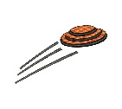
YORK CLAYBUSTERS 4-H TRAP TEAM INFORMAITON MEETING
The annual start of the season trap meeting will be on January 27 at the 4-H Building at the fairgrounds
at 4:00.
You must be 10 years of age as of January 1, 2019 and it only costs $5.00 to join.
Pick up more information in the office.

Advanced Services will be here to visit with you during 5A and 5B on February 21 to give you information about pollinating.

Students

Talk to Mr. Brackhan if you are interested in participating in archery this spring. 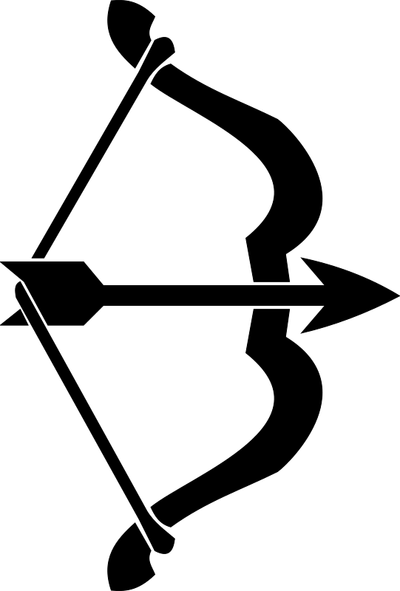

8th Graders need to bring a baby picture of yourselves (with your name on the back) to the office, or send your picture to linda.wilton@yorkdukes.org, A.S.A.P.
These pictures will be used for the 8th grade Continuation slide show.
----You will get your picture back

Would you like a chance to earn a day off from school, visit the University of Nebraska at Kearney, and compete with some of the best middle school math students in Nebraska? If you answered yes to any of these questions, please consider being a part of York Middle School’s MATHCOUNTS team!

YORK OPEN TENNIS NIGHTS FOR STUDENTS IN GRADES 6-8

Tuesday nights from 5:30 -6:30 starting tonight, January 8 and running through February 5 at the Cornerstone Activities Center indoor tennis courts at YHS.

No need to register, just show up with you $15.00 registration fee.

No tennis racket….NO PROBLEM! We’ll have one for you to use!

See you there!!!

YEARBOOKS ARE NOW ON SALE****Only $20.00

Come to the office anytime to purchase your 2018-2019 Yearbook!!

Staff Commons Duty
The week of 1/22—AM……....Mrs. DiToro / PM……….Mr. Forsch
ABSENCES:
6TH GRADE: Melissa Eckhart, Zeke Follett,
7th GRADE: Hadley Eckert, Shayla Rodriguez, Karter Switzer, Zeriah Tilton
8th GRADE: Cordelia Cole, Zach Hurley, Major Jager, Colin Pinneo,

It is the policy of York Public Schools not to discriminate on the basis of gender, disability, race, color, religion, marital status, age, or national origin in its educational programs, administration, policies, employment, or other district programs

